Lab Assignment 02

Variables and Datatypes



CSE110: Programming Language I

| **Difficulty** | **No of Tasks** | | | | **Points to Score** |
| --- | --- | --- | --- | --- | --- |
| Beginner | Intermediate | Expert | Total |
| **Classwork** | 2 | 2 | 1 | 5 | - |
| **Evaluation** | - | 1 | 1 | 2 | 20 |
| **Homework** | 3 | 3 | 2 | 9 | 80 |

The students must complete the classwork tasks in the lab class to obtain the lab performance marks. The lab instructors may show/explain a few of the classwork tasks to the students if necessary. Any plagiarism in classwork or homework will lead to the student getting zero in the entire assignment.

# Classwork

## **Beginner**

1. Find out which of the following are legal identifiers in Java, and which are not. Also, explain why the invalid ones are invalid. You can try to define each of these (items a to k below) as a variable in the Dr java interaction pane and find out.

The first one is done for you as an Example. If you want to define hungry, you have to try

**int hungry;**

a) hungry b) 2AB c) 312.2 d) MOBILE e) “Ans” f) $30

g) Yes/No h) student-id i) A+3 j) ‘X’ k) return

2. Write the Java code for the following:

1. Declare an **integer** variable. Initialize it with some value of your choice and print it to check the value has been stored properly.
2. Declare and initialize another **integer** variable. Add this to the first one and print out the result. Verify that the addition has been done correctly.
3. Now print the product and division of the two **integer** numbers.
4. Repeat exercises 2.1, 2.2, and 2.3 for variables of data type **double**. Verify your answers.
5. Repeat exercises 2.1, 2.2, and 2.3 for one **double** data type and one **integer** datatype. Verify your answers.
6. Repeat exercises 2.1 and 2.2 for variables of data type **String**. How does the addition operator work for Strings? What if the first variable is an integer and the second is a String and vice versa?

## **Intermediate**

3. Write a Java program declaring two integer variables and initializing them. Your task is to swap the values of these two variables. You must complete it using two different approaches.

* By Creating a third variable.
* Without creating any other variables.

4. Write a Java program to convert minutes into years and days. For simplicity, assume each year consists of 365 days.

Test Data:

Given the number of minutes: 3456789

Expected Output:

3456789 minutes is approximately 6 years and 210 days

### 

## **Expert**

5. Design a Java program to calculate Sin and Cos values from a right-angle triangle. Assume the values of a and b are 4.5 and 9.5 respectively. Finally, print the Sin and Cos values of angle A and angle B (SinA, CosA, SinB, CosB). The formulas to calculate these values are given below.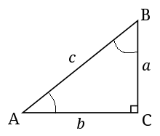

**Hint:** You need the values for all 3 sides to calculate both sin and cos. You are given only a and b. How would you get the value of c? You’ll need the help of Math.sqrt().

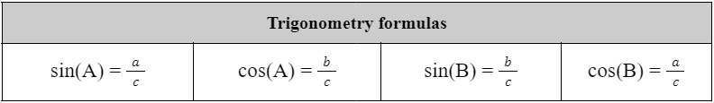

# 

# Class Evaluation

# 

## **Intermediate**

1. Suppose, you have three integer variables: a, b, c. Your first task is to assign the values 2, 5, 8 in these three variables. Next, you need to calculate and display the value of variable d using the following formula:



Write a Java program based on this mentioned scenario that prints the value of d after calculation.

[Answer: 27]

### 

## **Expert**

2. Write a Java program that displays the 2 rightmost digits of your student ID in reverse order. For example, if your student id is 23221454, you need to print 4, and then 5.

[Hint: Use the logic you used in one of the tasks in lab 1]

**Output:**

4

5

# 

# Homework

## **Beginner**

1. Write a Java code where given an integer we need to print the last 2 digits of that number.

2. Write a Java program that given a number in inches (you have to declare and initialize it yourself) converts it to meters. Note: One inch is 0.0254 meters.

**Test Data:**

Given a value for inch: 1000

**Expected Output:**

1000 inch is 25.4 meters

3. Write Java code that calculates and prints the circumference and area of a circle with a radius of 4 units.

## **Intermediate**

4. Write a Java Code to display the multiplication table for a given positive integer 'n'. The table should include the products of 'n' with each of the numbers from 1 to 10. For example, if n = 5, your code should output:

5 x 1 = 5

5 x 2 = 10

5 x 3 = 15

...

5 x 10 = 50

[You are not allowed to use loops to solve this problem.]

5. Draw the flowchart of a program that finds the sum of the first 100 positive numbers.

[Do NOT use loops, use the mathematical formula for calculating sum of arithmetic series given below].

**Note:**

S = n⁄2 (a + L), where n is the number of terms, a is the first term and L is the last term.

6. Write the Java code of a program that finds the sum of the first 100 positive numbers. You can verify your answer by calculating this sum manually.

[Do NOT use loops, use the mathematical formula for calculating sum of arithmetic series given below].

**Note:**

S = n⁄2 (a + L), where n is the number of terms, a is the first term and L is the last term.

## **Expert**

7. You have been traveling on a bike for 5 hours, 56 minutes, and 23 seconds. Assuming the distance covered is (Last 4 digits of your student ID) meter. Write a Java code to display the velocity of your bike in kilometers per hour and miles per hour. [Hint: 1 mile = 1609 meters]

**Test Data:**

Input distance in meters: 2500 // Assuming the last 4 digits are 2500

**Expected Output:**

Your velocity in km/h is 0.4208951

Your velocity in miles/h is 0.2615880

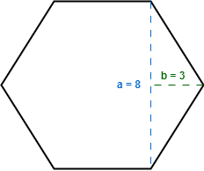

8. Assume a Hexagon where each of the sides are of the same length. From the visualization, we can see the values of *a* and *b* are given. Your task is to **(a) draw a flowchart** and **(b) write a Java code** to find the area and the circumference of the Hexagon.